RESOLUTION NO.__________

RE: CERTIFICATE OF APPROPRIATENESS UNDER THE
PROVISIONS OF THE ACT OF THE PENNSYLVANIA
LEGISLATURE 1961, JUNE 13, P.L. 282 (53
SECTION 8004) AND BETHLEHEM ORDINANCE NO.
3952 AS AMENDED.

WHEREAS, it is proposed to remove the deteriorated wood windows and replace them with Andersen Woodwright windows at 230 E. Wall St.

NOW, THEREFORE, BE IT RESOLVED by the Council of the City of Bethlehem that a Certificate of Appropriateness is hereby granted for the proposal.

Sponsored by: (s)

(s)

ADOPTED BY COUNCIL THIS DAY OF

(s)
President of Council

ATTEST:

(s)
City Clerk

HISTORICAL & ARCHITECTURAL REVIEW BOARD

The applicant proposes to remove the deteriorated wood windows and replace them with Andersen Woodwright windows at 230 E. Wall St.
APPLICATION #2:

Marie & Arnie Sposoto
203 E. Wall St.
Bethlehem, PA 18018

OWNER:

__________________________________________________________________

The Board upon motion by Phil Roeder and seconded by Connie Glagola adopted the proposal that City Council issue a Certificate of Appropriateness for the following:

1. Remove deteriorated wood windows and replace with Andersen Woodwright
windows.

2. New windows will have a white interior finish & dark brown exterior color.

3. Windows are to be one over one sash.

4. The motion was approved by a 3-1 vote.
__________________________________________________________________________

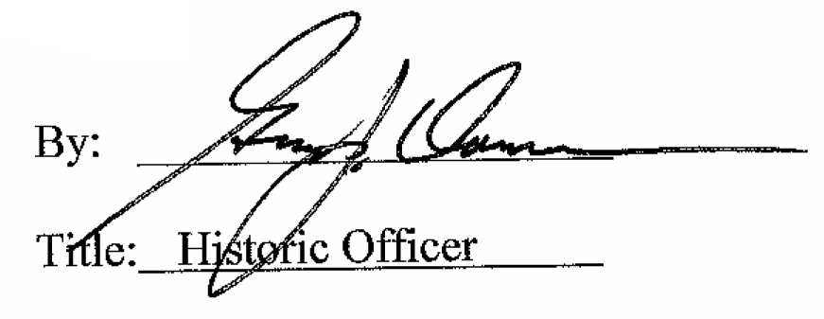

Date of Meeting: July 6, 2016

